14. Create an application which demonstrates use of AutoComplateView class
1. XML file

<?xml version="1.0" encoding="utf-8"?>
<RelativeLayout xmlns:android="http://schemas.android.com/apk/res/android"
android:layout_width="match_parent"
android:layout_height="match_parent">

<TextView
android:id="@+id/textView1"
android:layout_width="wrap_content"
android:layout_height="wrap_content"
android:layout_alignParentLeft="true"
android:layout_alignParentTop="true"
android:layout_marginTop="15dp"
android:text="what_is_your_favourite_programming_language" />

<AutoCompleteTextView
android:id="@+id/autoCompleteTextView1"
android:layout_width="wrap_content"
android:layout_height="wrap_content"
android:layout_alignParentLeft="true"
android:layout_below="@+id/textView1"
android:layout_marginLeft="36dp"
android:layout_marginTop="17dp"
android:ems="10"
android:text="">

<requestFocus />
</AutoCompleteTextView>

</RelativeLayout>

1. JAVA file
package com.example.checkbox;

import android.graphics.Color;
import android.os.Bundle;
import android.widget.ArrayAdapter;
import android.widget.AutoCompleteTextView;

import androidx.appcompat.app.AppCompatActivity;

public class AutoFill1 extends AppCompatActivity {
String[] language = {"C", "C++", "Java", ".NET", "python", "ASP.NET", "PHP", "ASP"};

@Override
protected void onCreate(Bundle savedInstanceState) {
super.onCreate(savedInstanceState);
setContentView(R.layout.autofill1);
ArrayAdapter<String> adapter = new ArrayAdapter<String>(this, android.R.layout.simple_list_item_1, language);
final AutoCompleteTextView actv = (AutoCompleteTextView) findViewById(R.id.autoCompleteTextView1);
actv.setThreshold(1);
actv.setAdapter(adapter);
actv.setTextColor(Color.RED);
}

}

Create an application which demonstrates use of AutoComplateView class and display the selected text when ok button is pressed.

2. XML file
<?xml version="1.0" encoding="utf-8"?>
<RelativeLayout xmlns:android="http://schemas.android.com/apk/res/android"
android:layout_width="match_parent"
android:layout_height="match_parent">

<TextView
android:id="@+id/textView1"
android:layout_width="wrap_content"
android:layout_height="wrap_content"
android:layout_alignParentLeft="true"
android:layout_alignParentTop="true"
android:layout_marginTop="15dp"
android:text="what is your favourite programming language " />

<AutoCompleteTextView
android:id="@+id/autoCompleteTextView1"
android:layout_width="wrap_content"
android:layout_height="wrap_content"
android:layout_alignParentLeft="true"
android:layout_below="@+id/textView1"
android:layout_marginLeft="36dp"
android:layout_marginTop="17dp"
android:ems="10"
android:text="">

<requestFocus />
</AutoCompleteTextView>
<TextView
android:id="@+id/textViewlang"
android:layout_width="match_parent"
android:layout_height="wrap_content"
android:layout_below="@+id/autoCompleteTextView1"
android:layout_marginTop="15dp"
android:text="You Selected :"
android:textAppearance="?android:attr/textAppearanceMedium" />

<Button
android:id="@+id/buttonSelectlang"
android:layout_width="wrap_content"
android:layout_height="wrap_content"
android:layout_marginTop="15dp"
android:layout_below="@+id/textViewlang"
android:layout_centerHorizontal="true"
android:text=" OK "
/>

</RelativeLayout>
2. JAVA file
package com.example.checkbox;

import android.graphics.Color;
import android.os.Bundle;
import android.view.View;
import android.widget.ArrayAdapter;
import android.widget.AutoCompleteTextView;
import android.widget.Button;
import android.widget.TextView;

import androidx.appcompat.app.AppCompatActivity;

public class AutoFill2 extends AppCompatActivity {

String[] language ={"C","C++","Java",".NET","iPhone","Android","ASP.NET","PHP","ASP"};
@Override
protected void onCreate(Bundle savedInstanceState) {
super.onCreate(savedInstanceState);
setContentView(R.layout.autofill2);
ArrayAdapter<String> adapter = new ArrayAdapter<String>(this,android.R.layout.select_dialog_item,language);
final TextView textViewSelectedlang=(TextView)findViewById(R.id.textViewlang);
Button btnSelectedlang=(Button)findViewById(R.id.buttonSelectlang);
final AutoCompleteTextView actv= (AutoCompleteTextView)findViewById(R.id.autoCompleteTextView1);
actv.setThreshold(1);
actv.setAdapter(adapter);
actv.setTextColor(Color.RED);

btnSelectedlang.setOnClickListener(new View.OnClickListener() {

public void onClick(View arg0) {
// TODO Auto-generated method stub

String language=actv.getText().toString();
textViewSelectedlang.setText("Favourite Language: "+language);

}
});

}
}

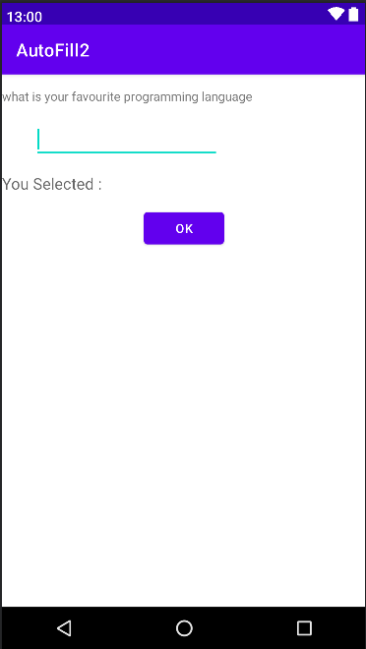

15. Create an application which demonstrates checkbox button event handling.

XML file
<?xml version="1.0" encoding="utf-8"?>
<LinearLayout xmlns:android="http://schemas.android.com/apk/res/android"
android:layout_width="match_parent"
android:layout_height="match_parent"
android:orientation="vertical">

<CheckBox
android:id="@+id/chk_c"
android:layout_width="wrap_content"
android:layout_height="wrap_content"
android:text="c" />

<CheckBox
android:id="@+id/chk_cpp"
android:layout_width="wrap_content"
android:layout_height="wrap_content"
android:text="cpp"
android:checked="true" />

<CheckBox
android:id="@+id/chk_java"
android:layout_width="wrap_content"
android:layout_height="wrap_content"
android:text="java" />

<Button
android:id="@+id/btnDisplay"
android:layout_width="wrap_content"
android:layout_height="wrap_content"
android:text="display" />

</LinearLayout>

JAVA file
package com.example.checkbox;

import androidx.appcompat.app.AppCompatActivity;

import android.os.Bundle;
import android.view.View;
import android.widget.Button;
import android.widget.CheckBox;
import android.widget.Toast;

public class MainActivity extends AppCompatActivity {

private CheckBox chk_c, chk_cpp, chk_java;
private Button btnDisplay;

@Override
protected void onCreate(Bundle savedInstanceState) {
super.onCreate(savedInstanceState);
setContentView(R.layout.checkbox);

addListenerOnChk_c();
addListenerOnButton();

}

// onclicklister on checkbox for c
public void addListenerOnChk_c() {
chk_c = (CheckBox) findViewById(R.id.chk_c);
chk_c.setOnClickListener(new View.OnClickListener() {

@Override
public void onClick(View v) {
if (((CheckBox) v).isChecked()) {
Toast.makeText(MainActivity.this,"use c", Toast.LENGTH_LONG).show();
}
}
});

}

public void addListenerOnButton() {

chk_c = (CheckBox) findViewById(R.id.chk_c);
chk_cpp = (CheckBox) findViewById(R.id.chk_cpp);
chk_java = (CheckBox) findViewById(R.id.chk_java);
btnDisplay = (Button) findViewById(R.id.btnDisplay);
btnDisplay.setOnClickListener(new View.OnClickListener() {

@Override
public void onClick(View v) {

StringBuffer result = new StringBuffer();
result.append("C check : ").append(chk_c.isChecked());
result.append("\nCPP check : ").append(chk_cpp.isChecked());
result.append("\nJAVA check :").append(chk_java.isChecked());
Toast.makeText(MainActivity.this, result.toString(),Toast.LENGTH_LONG).show();
}
});

}

}

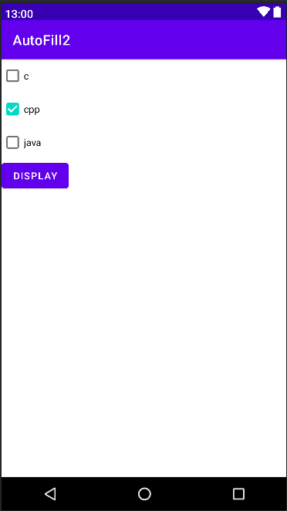

16. Create an application which demonstrates ListView with it event handling. Display the selected item and item no from the listview using Toast.
XML file
<?xml version="1.0" encoding="utf-8"?>
<LinearLayout xmlns:android="http://schemas.android.com/apk/res/android"
android:layout_width="match_parent"
android:layout_height="match_parent"
android:orientation="vertical">

<ListView
android:id="@+id/list"
android:layout_height="wrap_content"
android:layout_width="match_parent"
>
</ListView>

</LinearLayout>

JAVA file
package com.example.lifecycle;

import android.app.Activity;
import android.os.Bundle;
import android.view.View;
import android.widget.AdapterView;
import android.widget.ArrayAdapter;
import android.widget.ListView;
import android.widget.Toast;

public class List extends Activity {
ListView listView ;

@Override
protected void onCreate(Bundle savedInstanceState) {
super.onCreate(savedInstanceState);
setContentView(R.layout.list);

listView = (ListView) findViewById(R.id.list);
String[] subjects = new String[] { "MCAD", "ADV. JAVA", "COMP NETWORK", "PROJECT-II", "JAVA PROG.", "COA", "PROG. IN C", "PROG. IN C++" };
ArrayAdapter<String> adapter = new ArrayAdapter<String>(this, android.R.layout.simple_list_item_1, android.R.id.text1, subjects);
listView.setAdapter(adapter);
listView.setOnItemClickListener(new AdapterView.OnItemClickListener() {
@Override
public void onItemClick(AdapterView<?> parent, View view, int position, long id)
{
int itemPosition = position;
String itemValue = (String) listView.getItemAtPosition(position);
Toast.makeText(List.this, "Position :" +itemPosition+" ListItem : " +itemValue , Toast.LENGTH_LONG).show();
}
});
}

}

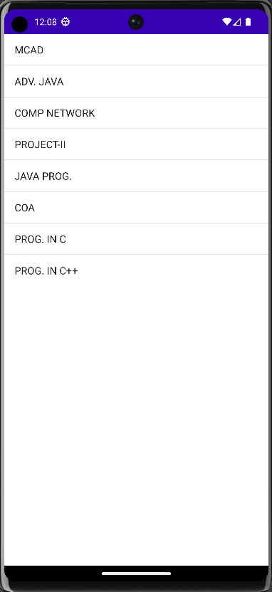

17. Create an application which demonstrates ListActivity with it event handling.
XML file
<?xml version="1.0" encoding="utf-8"?>
<LinearLayout xmlns:android="http://schemas.android.com/apk/res/android"
android:layout_width="match_parent"
android:layout_height="match_parent"
android:orientation="vertical">

<ListView
android:id="@+id/list"
android:layout_height="wrap_content"
android:layout_width="match_parent"
>
</ListView>

</LinearLayout>

JAVA file
package com.example.lifecycle;

import android.app.ListActivity;
import android.os.Bundle;
import android.view.View;
import android.widget.ArrayAdapter;
import android.widget.ListView;
import android.widget.Toast;

public class List2 extends ListActivity {
String days[]={"sunday", "monday", "tuesday", "Wednesday", "thursday", "friday", "satursday"};
public void onCreate(Bundle savedInstanceState)
{
super.onCreate(savedInstanceState);
setListAdapter(new ArrayAdapter<String>(this,
android.R.layout.simple_expandable_list_item_1,days));
}
public void onListItemClick(ListView parent, View v, int position, long id)
{
String item_name=days[position];
Toast.makeText(this, item_name, Toast.LENGTH_LONG).show();
}
}

